**MCQ**

1. A _____________ constraint requires that an entity belong to no more than one lower-level entity set.  
a) Disjointness  
b) Uniqueness  
c) Special  
d) Relational

2. Functional dependencies are a generalization of  
a) Key dependencies  
b) Relation dependencies  
c) Database dependencies  
d) None of the mentioned

3. The attribute name could be structured as an attribute consisting of first name, middle initial, and last name. This type of attribute is called  
a) Simple attribute  
b) Composite attribute  
c) Multivalued attribute  
d) Derived attribute

4. The attribute AGE is calculated from DATE_OF_BIRTH. The attribute AGE is  
a) Single valued  
b) Multi valued  
c) Composite  
d) Derived

5. TWhich of the following is a single valued attribute  
a) Register_number  
b) Address  
c) SUBJECT_TAKEN  
d) Reference

6. An attribute in a relation is a foreign key if the _______ key from one relation is used as an attribute in that relation.

a) Candidate b) Primary c) Super d) Sub

7. Using which language can a user request information from a database?

**a) Query** b) Relational c) Structural d) Compiler

8. The result which operation contains all pairs of tuples from the two relations, regardless of whether their attribute values match.

a) Join b) Cartesian product c) Intersection d) Set difference

9. The most commonly used operation in relational algebra for projecting a set of tuple from a relation is

a) Join b) Projection c) Select d) Union

10 ______ is a special type of integrity constraint that relates two relations & maintains consistency across the relations.  
a) Entity Integrity Constraints  
b) Referential Integrity Constraints  
c) Domain Integrity Constraints  
d) Domain Constraints

11. Which one of the following is used to define the structure of the relation, deleting relations and relating schemas?

a) DML(Data Manipulation Langauge) b) DDL(Data Definition Langauge)

c) Query d) Relational Schema

12. ____________ is preferred method for enforcing data integrity  
a) Constraints  
b) Stored Procedure  
c) Triggers  
d) Cursors

13 To remove a relation from an SQL database, we use the ______ command.  
a) Delete  
b) Purge  
c) Remove  
d) Drop table

14. Updates that violate __________ are disallowed.  
a) Integrity constraints  
b) Transaction control  
c) Authorization  
d) DDL constraints

15. The ________ clause is used to list the attributes desired in the result of a query.

a) Where b) Select c) From d) Distinct

16. In the given query which of the keyword has to be inserted?

INSERT INTO employee _____ (1002,Joey,2000);

a) Table b) Values c) Relation d) Field

17.SELECT name ____ instructor name, course id

FROM instructor, teaches

WHERE instructor.ID= teaches.ID;

Which keyword must be used here to rename the field name?

a) From b) Rename c) As d) Join

18. SELECT name

FROM instructor

WHERE deptname = ’Physics’

ORDER BY name;

By default, the order by clause lists items in ______ order.

a) Descending b) Any c) Same d) Ascending

19. _____ operator is used for appending two strings.

a) & b) % **c) ||** d) _

20. The union operation is represented by

a) ∩ b) U c) – d) *

21 The database administrator who authorizes all the new users, modifies the database and takes grants privilege is  
a) Super user  
b) Administrator  
c) Operator of operating system  
d) All of the mentioned

22. Which of the following is used to provide privilege to only a particular attribute?  
a) Grant select on employee to Amit  
b) Grant update(budget) on department to Raj  
c) Grant update(budget,salary,Rate) on department to Raj  
d) Grant delete to Amit

23. A _________ consists of a sequence of query and/or update statements.  
a) Transaction  
b) Commit  
c) Rollback  
d) Flashback

24. Which of the following makes the transaction permanent in the database?  
a) View  
b) Commit  
c) Rollback  
d) Flashback

25. CREATE TABLE Employee(Emp_id NUMERIC NOT NULL, Name VARCHAR(20) , dept_name VARCHAR(20), Salary NUMERIC UNIQUE(Emp_id,Name));

INSERT INTO Employee VALUES(1002, Ross, CSE, 10000)

INSERT INTO Employee VALUES(1006,Ted,Finance, );

INSERT INTO Employee VALUES(1002,Rita,Sales,20000);

What will be the result of the query?  
a) All statements executed  
b) Error in create statement  
c) Error in insert into Employee values(1006,Ted,Finance, );  
d) Error in insert into Employee values(1008,Ross,Sales,20000);

26. Aggregate functions are functions that take a ___________ as input and return a single value.

a) Collection of values b) Single value

c) Aggregate value d) Both Collection of values & Single value

27. Dates must be specified in the format  
a) mm/dd/yy  
b) yyyy/mm/dd  
c) dd/mm/yy  
d) yy/dd/mm

28.  Which of the following statement is used to remove the privilege from the user Amir?  
a) Remove update on department from Amir  
b) Revoke update on employee from Amir  
c) Delete select on department from Raj  
d) Grant update on employee from Amir

29. Tables in second normal form (2NF):

a) Eliminate all hidden dependenciesb) Eliminate the possibility of a insertion anomalies

c) Have a composite key d) Have all non key fields depend on the whole primary key

30. If we wish to grant a privilege and to allow the recipient to pass the privilege on to other users, we append the __________ clause to the appropriate grant command.  
a) With grant  
b) Grant user  
c) Grant pass privelege  
d) With grant option

**Section 'B'**

1. Make and E-R diagram of any online examination systems ?

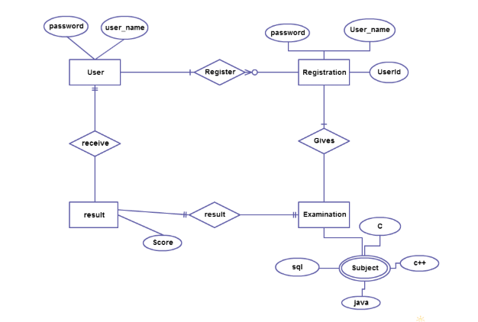

2.Define DDL DML and DCL commands with example.

**DDL(Data Definition Language) :**DDL or Data Definition Language actually consists of the SQL commands that can be used to define the database schema. It simply deals with descriptions of the database schema and is used to create and modify the structure of database objects in database.

**Examples of DDL commands:**

* [**CREATE**](https://www.geeksforgeeks.org/sql-create/) – is used to create the database or its objects (like table, index, function, views, store procedure and triggers).
* [**DROP**](https://www.geeksforgeeks.org/sql-drop-truncate/) – is used to delete objects from the database.
* [**ALTER**](https://www.geeksforgeeks.org/sql-alter-add-drop-modify/)-is used to alter the structure of the database.
* [**TRUNCATE**](https://www.geeksforgeeks.org/sql-drop-truncate/)–is used to remove all records from a table, including all spaces allocated for the records are removed.
* [**COMMENT**](https://www.geeksforgeeks.org/sql-comments/) –is used to add comments to the data dictionary.
* [**RENAME**](https://www.geeksforgeeks.org/sql-alter-rename/)–is used to rename an object existing in the database.

1. **DML(Data Manipulation Language) :**The SQL commands that deals with the manipulation of data present in database belong to DML or Data Manipulation Language and this includes most of the SQL statements.

**Examples of DML:**

* + [**SELECT**](https://www.geeksforgeeks.org/sql-select-clause/) – is used to retrieve data from the a database.
  + [**INSERT**](https://www.geeksforgeeks.org/sql-insert-statement/) – is used to insert data into a table.
  + [**UPDATE**](https://www.geeksforgeeks.org/sql-update-statement/) – is used to update existing data within a table.
  + [**DELETE**](https://www.geeksforgeeks.org/sql-delete-statement/) – is used to delete records from a database table.

1. **DCL(Data Control Language) :**DCL includes commands such as GRANT and REVOKE which mainly deals with the rights, permissions and other controls of the database system.

**Examples of DCL commands:**

* + **GRANT**-gives user’s access privileges to database.
  + **REVOKE**-withdraw user’s access privileges given by using the GRANT command.

1. What is decomposition ? What are the different types anomalies of Normalization.

**Decomposition in DBMS** removes redundancy, anomalies and inconsistencies from a database by dividing the table into multiple tables.

Anomalies in database make the data handling difficult as the data grows. It makes it harder to maintain data integrity. In most of types of anomalies it even becomes a task to make the data consistent.

Suppose a database table with bad design

|  |  |  |  |  |  |
| --- | --- | --- | --- | --- | --- |
| **Article ID** | **Article Name** | **...** | **...** | **Author** | **Author Profile** |
| 186749 | Entity Relationship Model | ... | ... | A | profile-link-a |
| 352509 | Databases | ... | ... | B | profile-link-b |
| 730645 | Normalization | ... | ... | A | profile-link-a |

**Insertion Anomaly** It becomes difficult to insert data since we must add complete details of author with every article. The data becomes prone to inconsistency.

**Updation Anomaly** Just like insertion, while updating LinkedIn Profile of an author, let's suppose, we must update it in every article of that author.

**Deletion Anomaly** Suppose we delete a couple of articles and it eliminates an author. We may not want that. This scenario is known as deletion anomaly. It occurs when a last row of such design is deleted, and no such row is left which can tell that an author exists.

4. Normalize the following database table upto BCNF.

|  |  |  |  |  |  |  |
| --- | --- | --- | --- | --- | --- | --- |
| ProjNum | ProjName | EmpName | Job_Class | Charge_Hour | Hours_worked | Total_Charge |
| 15 | Evergreen | Prithivi | Engineer | $25 | 145 | 3625 |
| 15 | Evergreen | Manisha | DBA | $26 | 220 | 5720 |
| 18 | Kulekhani | Rishav | Engineer | $25 | 220 | 5500 |

1. Define Referential integrity Constraint. What is reason for implementing referential integrity in database ?

A **referential integrity constraint** is **defined** as part of an association between two entity types. The**definition** for a **referential integrity constraint**specifies the following information: The principal end of the **constraint**.

**Advantages of Referential Integrity Constraints**

Using a relational [database management](https://www.lifewire.com/database-management-system-1019609) system with referential integrity offers several advantages:

* Prevents the entry of duplicate data
* Prevents one table from pointing to a nonexistent field in another table
* Guarantees consistency between "partnered" tables
* Prevents the deletion of a record that contains a value referred to by a foreign key in another table
* Prevents the addition of a record to a table that contains a foreign key unless there is a primary key in the linked table

1. Explain any one database recovery algorithm.

## **Crash Recovery**

DBMS is a highly complex system with hundreds of transactions being executed every second. The durability and robustness of a DBMS depends on its complex architecture and its underlying hardware and system software. If it fails or crashes amid transactions, it is expected that the system would follow some sort of algorithm or techniques to recover lost data.

1. Describe the serial and serializable schedule ? Why serializable schedule is consider correct ?

**Serial Schedule** − It is a schedule in which transactions are aligned in such a way that one transaction is executed first. When the first transaction completes its cycle, then the next transaction is executed. Transactions are ordered one after the other. This type of schedule is called a serial schedule, as transactions are executed in a serial manner.

Serial Schedule

• Transactions execute fully. • One at a time. • No interleaving. • Different orders of execution may produce different  final values

Serializable Schedule

• Interleaved. • Equivalent to SOME serial schedule. • Equivalence does NOT mean "ending up with the same values  as". • Equivalence cannot depend on initial values of database items. • Cannot depend on values written  DB doesn’t know logic of transaction. • Depends only on order of operations.

1. What is specialization and generalization ? Describe with suitable examples.

## Generalization

**Generalization** is a bottom-up approach in which two lower level entities combine to form a higher level entity. In generalization, the higher level entity can also combine with other lower level entities to make further higher level entity.

It's more like Superclass and Subclass system, but the only difference is the approach, which is bottom-up. Hence, entities are combined to form a more generalised entity, in other words, sub-classes are combined to form a super-class.

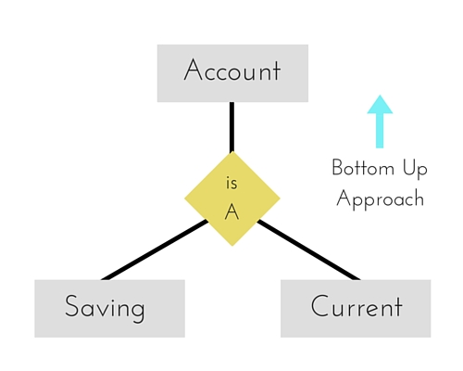

For example, **Saving** and **Current** account types entities can be generalised and an entity with name **Account** can be created, which covers both.

## Specialization

**Specialization** is opposite to Generalization. It is a top-down approach in which one higher level entity can be broken down into two lower level entity. In specialization, a higher level entity may not have any lower-level entity sets, it's possible.

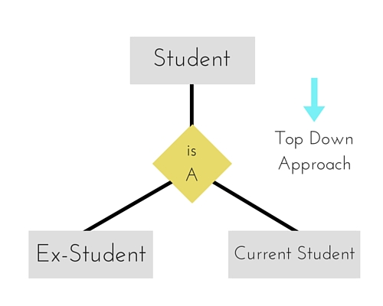

**Section C**

* 1. Draw and ERD of Hospital Management System. The E-R diagram of hospital management system shows all the visual instrument of database tables and the relations between patient, Nurses, Hospitals, Medicines etc. The main entities of the Hospital Management system are hospitals, patients, Doctors, Nurses, Appointments and Medicines. Assume attributes of entities by yourself and Draw the ER diagram.

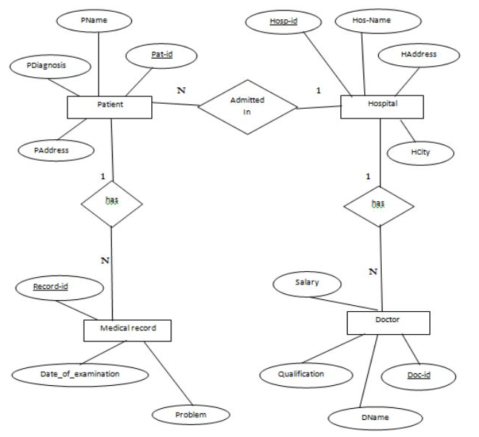

2. Sailors(*sid:* integer, *sname:* string, *rating:* integer, *age:* real) [ Structured Query Language ]

Boats(*bid:* integer, *bname:* string, *color:* string)

Reserves(*sid:* integer, *bid:* integer, *day:* date

a. find the sum of rating of all sailors.

b. find average age of all sailors with a rating of 9.

c. find the age of the youngest sailors for each rating level.

d. suppose we need to insert a new record of Sailors of id is11, name is “Rahul”, rating is 9 and of age is 29 then we write following SQL query

e. Remove all tuples of Sailors whose age is less than 30 and rating greater than 7

3. What is transaction? Explain concurrent transactions with example. [ Transaction and Concurrency Control ]

A **transaction** is a logical unit of processing in a**DBMS** which entails one or more database access operation. In a nutshell, database **transactions**represent real-world events of any enterprise. ... Only once the database is committed the state is changed from one consistent state to another.